- REPORT ON

UNSUPERVISED LEARNING FROM INTERNET

By

Mayank Dhaka 201H1030041H

AT

IBM INDIA SOFTWARE LABS
BANGALORE

A Practice School II Station of



BIRLA INSTITUTE OF TECHNOLOGY & SCIENCE,
PILANI APRIL 2018

1

- REPORT ON

UNSUPERVISED LEARNING FROM INTERNET

By

Mayank Dhaka 2016H1030041H

M.E. Computer Science

Prepared in the partial fulfillment of the
Practice School II Course

AT

IBM INDIA SOFTWARE LABS

BANGALORE

A Practice School II Station of


BIRLA INSTITUTE OF TECHNOLOGY & SCIENCE,
PILANI APRIL 2018

2



ACKNOWLEDGEMENT

Even though I have made efforts in this project, it would not have been possible without the kind support and help of some of the important people. I would like to extend my sincere thanks to all of them.

I am highly thankful to IBM Support Team members for their guidance and constant supervision as well as for providing necessary information regarding the project & also for their support in proper functioning of the project.

I would like to put in my word of thanks to my manager, Mr. Amitava Kundu, IBM ISL, for giving me this opportunity to work in his team and setting up a platform for my long career to come. I extend my thanks for all the guidance and support extended by him throughout the project.

I extend my immense gratitude to my mentor, Mr. You Peng Huang, IBM ISL, who have overseen this project since its inception, lead me to look at the problem from different perspectives and insisted in setting higher standards to us.

I would also like to thank my PS faculty Mr. Pradheep Kumar, for his time to time valuable guidance and kind support.

At last I would like to thank all my team mates who helped me to understand various technologies and tools.

3

BIRLA INSTITUTE OF TECHNOLOGY AND SCIENCE
PILANI (RAJASTHAN)

Practice School Division

Station: IBM ISL Centre: Bangalore

Duration: 5 months Date of Start: 5th Jan 2018

Date of Submission: 02-JUNE-2018

Title of the Project: Unsupervised learning from Internet

ID No. /Name(s)/: 2016H1030041H / Mayank Dhaka

Discipline of the Student: M.E. Computer Science

Name(s) and Designation(s) of the expert(s):
Mr. Amitava Kundu, Solution Architect
Mr.You Peng Huang, Project Lead

Name(s) of the PS Faculty: Mr. Pradheep Kumar

Key Words: NLP,Cypher Query, Information Retrieval

Project Areas: Artificial Intelligence, Q&A

4



ABSTRACT

The idea is that we utilize the internet resources, such as wikipedia, google search, etc, in unsupervised learning.

It simulates a human learning behavior. When we have a topic, it may be few keywords or a term we do not understand too much. Human being would like to search around the related staff around the keywords or the term and quickly determine the relationship that exist between knowledges. That is a process of “learning”

The program utilize the internet resource to explore the related knowledge and get the knowledge graph or knowledgebase related. Then answer questions.
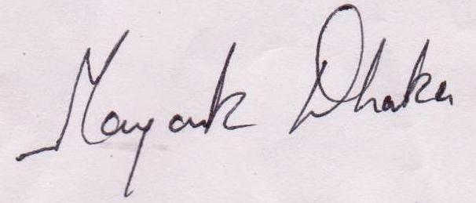

Signature(s) of Student(s) Signature of PS Faculty

Date: 02/JUNE/2018

BIRLA INSTITUTE OF TECHNOLOGY AND SCIENCE
PILANI (HYDERABAD)

PRACTICE SCHOOL DIVISION

5

BIRLA INSTITUTE OF TECHNOLOGY AND SCIENCE

PILANI (HYDERABAD)

PRACTICE SCHOOL DIVISION

Response Option Sheet

Station: IBM ISL Center: Bangalore

ID No. & Name(s):2016H1030041H, Mayank Dhaka

Title of the Project: Unsupervised Learning from Internet

Usefulness of the project to the on-campus courses of study in various disciplines. Project should be scrutinized keeping in view the following response options. Write Course No. and Course Name against the option under which the project comes.

Refer Bulletin for Course No. and Course Name.
Code No. | Response Option | Course No.(s) & Name
1. | A new course can be designed out of this
 | project.
2. | The project can help modification of the
 | course content of some of the existing
 | Courses
3. | The project can be used directly in some of
 | the existing Compulsory Discipline Courses
 | (CDC)/ Discipline Courses Other than
 | Compulsory (DCOC)/ Emerging Area (EA),
 | etc. Courses
4. | The project can be used in preparatory
 | courses like Analysis and Application
 | Oriented Courses (AAOC)/ Engineering
 | Science (ES)/ Technical Art (TA) and Core
 | Courses.
5. | This project cannot come under any of the
 | above mentioned options as it relates to the
 | professional work of the host organization.

_________________
Signature of Student
Date: 02/JUNE/2018

________________
Signature of Faculty
Date:

6

Table of Contents

1 Introduction 8

2 Overview 9

2.1 Data Retrieval 9

2.1.1 Sample Code 9

2.1.2 Sample Result …………………………………………………………………………………………………………………….. 10

2.2 Knowledge Database ……………………………………………………………………………………………………………………

2.2.1 Neo4j Database……………………………………………………………………………………………………………………………. ………..14

2.3 Create GUI……………………………………………………………………………………………………………… 15

2.3.1 Sample Code………………………………………………………………………………………………………………………………..15

2.3.2 Sample Result……………………………………………………………………………………………………………………………….16

3 Conclusions ……………………………………………………………………………………………………………………………………… 17

- References ………………………………………………………………………………………………………………………………………. 18

7

- Introduction

IBM Watson is widely known for its cognitive capabilities. It is used for object recognition, medical diagnostics, language translation, natural language generation etc. It is one of the leading cognitive services in the world right now. Ask Watson is a barebones chatbot platform powered by IBM Watson.

It is used by customer to ask various questions regarding the services provided by the IBM
But every time a question is asked data retrieved is based on page rank or based on some oter metric used to define popularity of the content . But every time a content is returned does not totally interest the customer as the information person actually required consist of very less percentage of returned material. So a mechanism is needed to return only relevant and more precise information about the topic user is interested in.

8

- Overview

Traditional data analysis involves searching for established patterns and keywords in limited data sets, then performing operations on the result. But IBM Watson is leading a watershed shift to digital intelligence: finding meaning by discovering previously unseen patterns, drawing new inferences, and identifying new relationships from vast amounts of data. At Watson we can transform companies and disrupt entire markets by building cognitive thinking into every application we build, using systems that learn to power enterprises that learn.What distinguishes our cognitive clients?They engage more deeply with customers, students, patients, lawyers, citizens.Their professionals gain elevated expertise, keeping pace with the unprecedented information explosion.Their products and services sense, reason, and learn about their business, its customers, its markets.Their operations respond in real-time to complex changes in content, sentiment, costs, merchandising, inventory, promotion. They shine headlights into the future, seeing patterns invisible to traditional research. Watson is changing IBM’s relationship with our clients, using the breadth and depth of our entire company to help them rapidly grasp the power of cognitive computing.
The idea is that we utilize the internet resources, such as wikipedia, google search, etc, in unsupervised learning.

It simulates a human learning behavior. When we have a topic, it may be few keywords or a term we do not understand too much. Human being would like to search around the related staff around the keywords or the term and quickly determine the relationship that exist between knowledges. That is a process of “learning”

The program utilize the internet resource to explore the related knowledge and get the knowledge graph or knowledgebase related. Then answer questions.

The Data Retrieval product is basically divided into three phases

2.1 Data Retrieval

- Pull the structure or semi-structured data from targeted site for a specific topic.
For example, get all Q&As on blockchain from stackoverflow (around 1.7K topics) and get the Question/Answer. Find a category in general domain or technical domain, such as Artificial Intelligence https://en.wikipedia.org/wiki/Category:Artificial_intelligence

2.1.1 Sample Code
from bs4 import BeautifulSoup as soup
from urllib.request import urlopen
import os
from neo4jrestclient.client import GraphDatabase
from neo4jrestclient import client
times = int(input("No.of Brand name to search"))
listOfproduct=[]
for i in range (times):
listOfproduct.append(input("Type Brand_name to search"))
#name = raw_input("Type name to search")
#my_url='http://www.nbcrna.com/exams/nce-resources/nce-see-exam-tutorial'
for query in listOfproduct:
query = query.lower()
string = "https://www.flipkart.com/search?q=%20&otracker=start&as-show=on&as=off"
my_url = string[:34] + query + string[34:]
def fetchdata(url):
try:
client=urlopen(my_url)
return (client)
except:
print ("failed try again")
return fetchdata(url)
uClient=fetchdata(my_url)
page_html=uClient.read()
uClient.close()
page_soup=soup(page_html ,"html.parser")
containers=page_soup.findAll("div", {"class": "col _2-gKeQ"})
container=containers[0]
f=open("C:/Users/IBM_ADMIN/AppData/Roaming/Neo4j Desktop/Application/neo4jDatabases/database-7f83e15b-2553-485c-ac9b-8721d02222e6/installation-3.3.3/import/"+query+".csv","w")
headers = "Product_name,Price,Ratings\n"
if(os.stat("C:/Users/IBM_ADMIN/AppData/Roaming/Neo4j Desktop/Application/neo4jDatabases/database-7f83e15b-2553-485c-ac9b-8721d02222e6/installation-3.3.3/import/"+query+".csv").st_size == 0):
{
f.write(headers)
}
for container in containers:
product_name=container.div.img["alt"]
price = container.findAll("div", {"class": "col col-5-12 _2o7WAb"})
product_price=price[0].text
trim_price=''.join(product_price.split(','))
trim1_price=trim_price.split('₹')
addrs_price= ''.join(trim1_price[1])
addrs1_price=addrs_price.split('E')
addrs2_price = addrs1_price[0].split('U')
final_price=''.join(addrs2_price)
ratings = container.findAll("div", {"class": "niH0FQ"})
try:
product_ratings = ratings[0].text
split_ratings = product_ratings.split(' ')
final_ratings = split_ratings[0]
except:
product_ratings='ratings not given'
print(product_name.replace(',','|') +',' + final_price + ',' + final_ratings + '\n')
f.write(product_name.replace(',','|') +',' + final_price + ',' + final_ratings + '\n')
f.close()

9

2.1.2 Sample Result

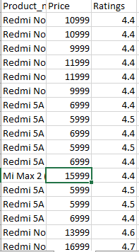

2.2 Knowledge Dataabse

Put the structured knowledge retrieve from previous step to knowledge graph (graph database),.

we tried by using manual way firstly then call API to do it automatically. Then we

utilize the graph database query to practice the Q&A with machine.

2.2.1 Neo4J Graph Database
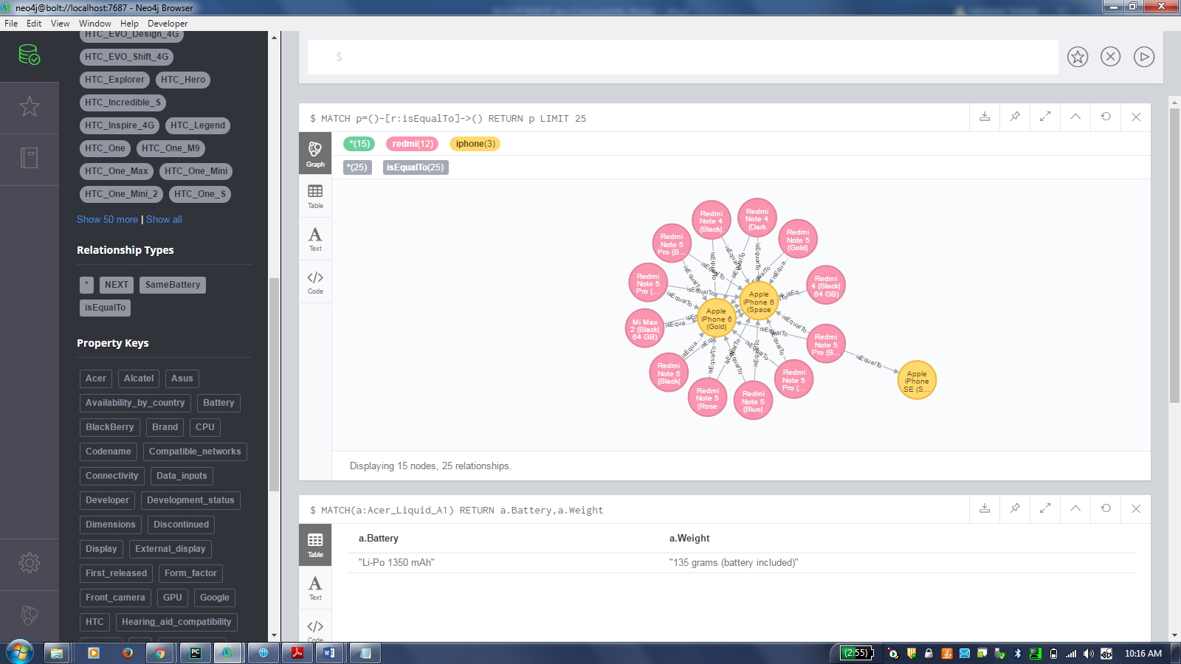

12

2.3 Creating GUI

Convert the questions in natural language to query of graph database. We can use pattern

way (easier) or machine learning (harder).First I tried with patern way

Given a topic (keywords or terms, such as Blockchain)

A text knowledgebase could be created for the topic with as much as possible labeled

data from web page structure.

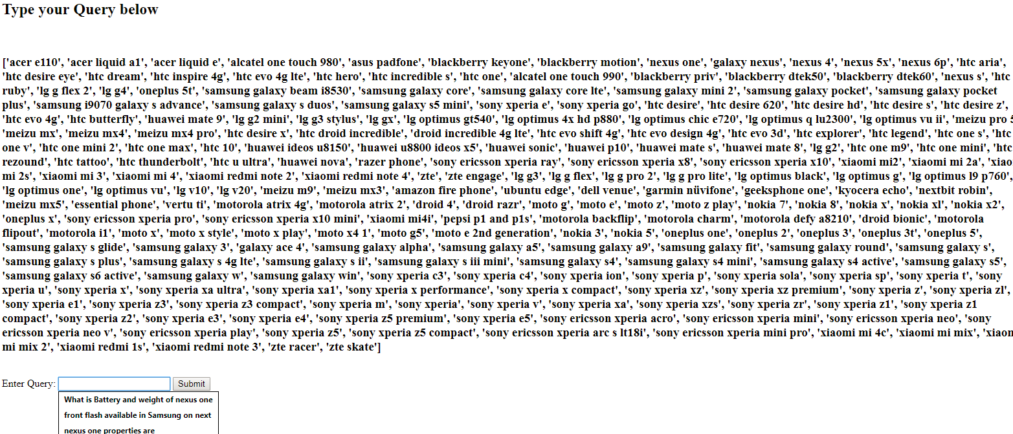

2.3.1 Sample Code
from bs4 import BeautifulSoup as soup
from urllib.request import urlopen
import os
from neo4jrestclient.client import GraphDatabase
from neo4jrestclient import client
db = GraphDatabase("http://localhost:7474", username="neo4j", password="shaktisingh")
labelquery="MATCH (r) RETURN labels(r);"
results = db.query(labelquery, returns=(str))
label=[]
for r in results:
ttt=r[0]
ttt1=ttt.replace('[','')
ttt2=ttt1.replace(']','')
ttt3=ttt2.replace("'","")
if ttt3=="Word":
continue
else:
label.append(ttt3)
label=list(set(label))
print(label)
## MATCH (p) RETURN keys(p)
property_query="MATCH (p) RETURN keys(p);"
results = db.query(property_query, returns=(str))
property=[]
for p in results:
property=property+p
property = ''.join(property)
property=property.replace('[', '')
property=property.replace(']', '')
property=property.replace('"', '')
property=property.replace("'", '')
property=property.replace(' ', '')
property=property.split(',')
property=list(set(property))
print(property)
Natural_Language_query=input("enter the query ")
Natural_Language_query=Natural_Language_query.split(" ")
Label=[]
Property=[]
for word in Natural_Language_query:
if word in label:
Label.append(word)
continue
elif word in property:
Property.append(word)
#print(Label)
#print(Property[1])
for node in Label:
query = "MATCH"
query=query+'('+node+':'+node+'),'
query = query[:-1]
query=query+" RETURN "
iteration=len(Property)
for key in Property:
query=query+node+'.'+key+','
query = query[:-1]
query=query+";"
results = db.query(query)
i=0
for r in results:
print("\n")
for i in range(iteration):
print("%s %s(%s)" % (node,Property[i],r[i]))

2.3.2 Sample Result

enter the query What is the Battery and Weight of Acer_Liquid_A1 and Moto_E

Acer_Liquid_A1 Battery(Li-Po 1350 mAh)
Acer_Liquid_A1 Weight(135 grams (battery included))

Moto_E Battery(1,980 mAh)
Moto_E Weight(142 g (5.0 oz))

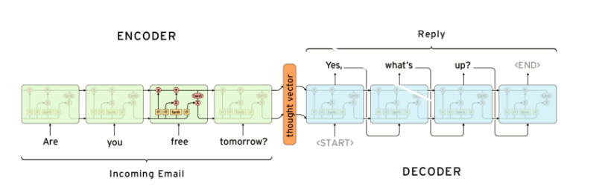
3.SEQUENCE TO SEQUENCE MODEL

This the training model implemented to convert Queries asked by user in natural language to corresponding cypher queries which then are used to extract information from the neo4j database
And again presented to user in natural language.

It is achieved by using encoder-decoder mechanism,where encoder takes a sequence(sentence) as input and processes one symbol(word) at each timestep. Its objective is to convert a sequence of symbols into a fixed size feature vector called thought vector that encodes only the important information in the sequence while losing the unnecessary information.
From the context, the decoder generates another sequence, one symbol(word) at a time. Here, at each time step, the decoder is influenced by the context and the previously generated symbols

Here is the pic of working SEQ2SEQ model where in left side there are queries asked in natural language and in right side their corresponding Cypher queries

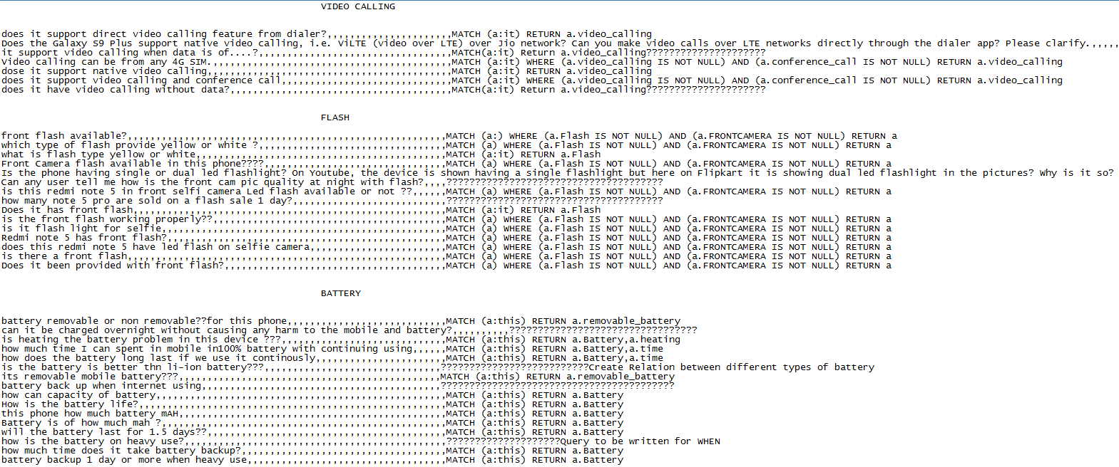

4.Conclusion

Final product to answer Natural Language question by training it with Sample

Question asked by the user in that field and their corresponding query written side to them.

find an IBM product such as B2B. think about what kind of questions user would like to ask

and how you organize and put the knowledge into graph database.

5.References

  - https://github.ibm.com/
  - https://github.com/tensorflow/tensorflow/tree/master/tensorflow/contrib/seq2seq/python/ops
  - https://neo4j.com/
  - https://en.wikipedia.org/wiki/Xiaomi_Redmi

More precise ,regulate

Challenges to improve ai technology

Customized reqirement

16

17

18

